ServerLoad Service
Detailed Design Document
Version <0.1>
Revision History
Date | Version | Description | Author
2007-10-21 | 0.1 | Initial draft | Ken Qian

Table of Contents
1. Introduction 4
1.1 Purpose 4
1.2 References 4
1.3 Abbreviation 4
2. System Overview 4
2.1 System Requirement 4
2.2 System Logic Overall Structure 5
3. Server Load from Axiom 6
3.1 Data Definition 6
3.2 Sample XML 7
4. Server Load from Tianshan 8
4.1 Change of Data Definition 9
4.1.1 AppType 9
4.1.2 NodeGroup 9
4.1.3 CMGroup 9
4.1.4 Instance 9
4.2 Sample XML 10
5. OTE combines server load data from Axiom and Tianshan 11
5.1 Random arithmetic to recommend CM instance 11
5.2 Support NAT IP mapping 11
5.3 Server load data in Cache 11
5.4 Returned data to STB 11
6. Work Flow 12
7. Interface List 15
7.1 Interface with STB 15
7.2 Interface Reference Table 15

Introduction

Purpose
This document is the summary design of ServerLoad Serivce component as part of system working with Axiom and Tianshan.

References

Abbreviation
- CM Connection Management
- OTE Online Transaction Engine
- STB Set Top Box
- WFES Web Front End System

System Overview

System Requirement
- Collect server load data from Axiom system
- Collect server load data from Tianshan system
- ServerLoad Service saves and periodically updates server load data into one or multiple OTE database instances.
- The database scheme for Axiom and TianShan server load are same. But they are distinguished for both ServerLoad Service and OTE component.
- One ServerLoad Service instance supports collecting server load data from one or multiple Axiom and TianShan systems at the same time.
- The collecting operation to one system (Aximon or TianShan) does not affect the server load data generated by other systems.
- To the fields which does not defined in Axiom generated server load xml, but they are a part of TianShan, must be configurable, includes “CMGroupID”, “ServerType”, “SessionProtocolType”, “HostName”. ServerLoad Service uses the configured value to update the database.
- Since the “port” in Axiom generated server load xml file does not represents the RTSP or DSMCC port for streaming control, it is just an internal port. So the “port” also is configurable, and if configured, ServerLoad Service must use the configured value to update OTE database, instead of the one read from server load xml. And this is effective for TianShan.

System Logic Overall Structure
The overall structure is as:
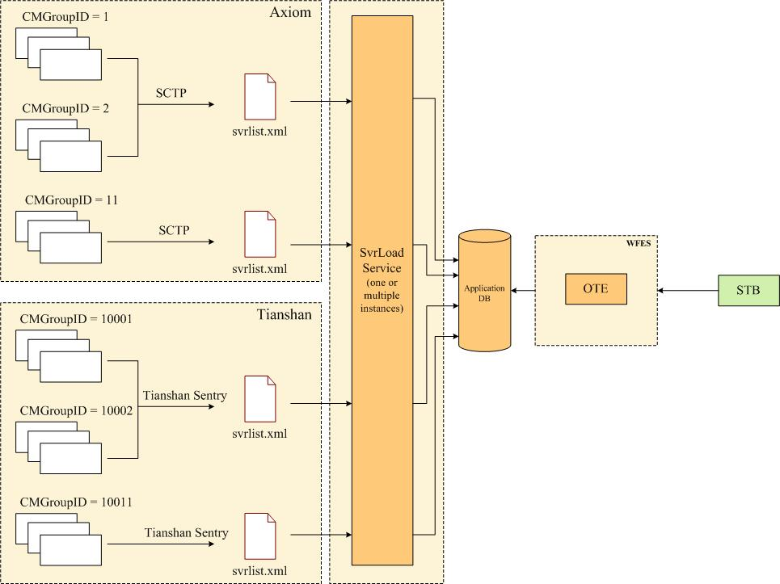

Server Load XML from Axiom
SCTP service in Axiom generates the server load data file to present the load of CM instance in CMGroups.

Data Definition
The document type definition (DTD) for server load is as:

<!-- Tag that denotes XML file type -->
<!ELEMENT SrvrList (Header, CMGroup*, SCTPGroup*)>

<!-- Tag that denotes Header information for the file -->
<!ELEMENT Header (Version, DateTime, Interval)>

<!-- Tag that denotes information for groups of Connection Manager server instances -->
<!ELEMENT CMGroup (PGLevel, AppType+, NodeGroup+, Instance+)>

<!-- Tag that denotes information for groups of SCTP server instances -->
<!ELEMENT SCTPGroup (Instance+)>

<!-- Tag that denotes information about a specific instance of either a Connection Manager Server or an SCTP Server -->
<!ELEMENT Instance (IPAddress, Port, Load, LifeTime)>

<!-- Version is of the form MajorVersion.MinorVersion
- for example, 1.2 -->
<!ELEMENT Version (#PCDATA)>

<!-- DateTime is of the form MM.DD.YYYY.HH.MM.SS and is the “Universal Coordinated Time” (UTC) (formerly called Greenwich Mean Time (GMT))
- for example, 10.17.2000.9.45.22 -->
<!ELEMENT DateTime (#PCDATA)>

<!—Interval denotes the interval time for regeneration of this file in seconds by the VOD server - for example, 300 -->
<!ELEMENT Interval (#PCDATA)>

<!-- PeerGroupLevel is an integer value between 1 and 5. When there are multiple CM instance groups to choose from that can serve a specific node group and application type, first select the group with the highest PeerGroupLevel – i.e. the instances located closest to the settop box - then select among the instances in that group to find the instance with the lowest load. -->
<!ELEMENT PGLevel (#PCDATA) >

<!-- Application Type – an ITV system can support many different types of applications:
Movies on Demand (MOD), Near Video on Demand (NVOD), Sports on Demand (SOD), etc. Only select the CM instance group that can support the application type you’re interested in. Each application type is assigned an AppUID. The application UID can be obtained from your site administrator. He or she can obtain them from the SeaChange AssetManagement Utility -->
<!ELEMENT AppType (#PCDATA) >

<!-- NodeGroup is a Hexidecimal string denoting the six byte NodeGroupId as defined in the SeaChange Client Protocols spec - for example, 0X0000002C3f4e -->
<!ELEMENT NodeGroup (#PCDATA)>

<!-- IPAddress is the IP address of the server instance in dot notation
- for example, 192.168.128.148 -->
<!ELEMENT IPAddress (#PCDATA)>

<!-- Port is the port number of the server instance (in integer)
- for example, 13816 -->
<!ELEMENT Port (#PCDATA)>

<!-- Load is a number between zero (0) and a hundred one (101) denoting the percent load on the server. A value of 101 means that the server’s unavailable and cannot be used by a settop. -->
<!ELEMENT Load (#PCDATA)>

<!—LifeTime is the time in seconds from the time this file was generated to the current time for which the information in this file is valid for a server. If the current time on your machine minus the DateTime element for this file is greater than the LifeTime for a server, the server information is said To have “expired”. If all the servers have expired for a CMGroup or SCTP group, you have stale data and should generate an alarm. However, it’s the only data you have so – after alarming – continue to use the data for assign servers to settops rather than denying service. -->
<!ELEMENT LifeTime (#PCDATA)>

Sample XML
The sample server load XML is as:
<?xml version="1.0"?>
<SrvrList>
<Header>
<Version>1.2 </Version>
<DateTime>10.16.2000.09.44.21</DateTime>
<Interval>120 </Interval>
</Header>
<CMGroup>
<AppType>0X0000138F</AppType>
<AppType>0X0000137F</AppType>
<PGLevel>5</PGLevel>
<NodeGroup>0X000000954F2E</NodeGroup>
<NodeGroup>0X000000954F1E</NodeGroup>
<NodeGroup>0X000000954F0E</NodeGroup>
<Instance>
<IPAddress>192.168.129.148</IPAddress>
<Port>13192</Port>
<Load>50</Load>
<LifeTime>300 </LifeTime>
</Instance>
<Instance>
<IPAddress>192.168.129.147</IPAddress>
<Port>13193</Port>
<Load>30</Load>
<LifeTime>300 </LifeTime>
</Instance>
</CMGroup>
<CMGroup>
<AppType>0X0000138F</AppType>
<PGLevel>4</PGLevel>
<NodeGroup>0X000000954F2E</NodeGroup>
<NodeGroup>0X000000954F1E</NodeGroup>
<NodeGroup>0X000000954F0E</NodeGroup>
<Instance>
<IPAddress>192.168.128.148</IPAddress>
<Port>13816</Port>
<Load>10</Load>
<LifeTime>300 </LifeTime>
</Instance>
<Instance>
<IPAddress>192.168.128.147</IPAddress>
<Port>13817</Port>
<Load>20</Load>
<LifeTime>300 </LifeTime>
</Instance>
</CMGroup>
<SCTPGroup>
<Instance>
<IPAddress>192.168.129.146</IPAddress>
<Port>13914</Port>
<Load>20</Load>
<LifeTime>300</LifeTime>
</Instance>
</SCTPGroup>
</SrvrList>

Server Load XML from Tianshan
TianShan server load xml definition is compatible with Axiom, but extensible than Axiom. So there are some additional fields (properties) are new comparing with Aximon. They are: CMGroupID, ServerType, SessionProtocolType, HostName. But there is no SCTPGroup in TianShan generated xml file.

New Fields Definition

AppType
AppType is application-id. In Axiom, it is hex format with “0X”as prefix. In Tianshan, it is a string with HEX number, uppercase and with 0 as prefix (without 0X), the length is 8.
- 60010001: for MOD application
- 60010002: for nPVR application
- 60020001: for PauseTV application
- 60020002: for StartOverTV application

NodeGroup
- In Axiom, it is hex format with “0X”as prefix.
- In Tianshan, it is an integer (decimal numbers).

CMGroup
Add attributes to CMGroup:
- CMGroupID: The id of the CM group, it is unique in the system, and for Tianshan system, it is mandatory.
The CMGroup ID should be configurable in Tianshan system for each CMGroup. The suggested ID is from 10000. The range of 0~10000 is reserved for Axiom.
Server load service will use the CMGroupID to refresh the existing data in OTE database.
- ServerType: the type of CMGroup
The server type is 1 for Axiom
The server type is 2 for Tianshan

Instance
Add attribute and element to Instance:
- SessionProtocolType: it is for the session setup protocol: RTSP or DSM-CC. it is required attribute and no default value. The value is “RTSP” or “DSM-CC”.
- HostName: the host name of the CM instance. It is optional.

Sample XML
The Sample XML of Tianshan server load data is as:
<?xml version="1.0"?>
<SrvrList>
<Header>
<Version>1.2 </Version>
<DateTime>10.16.2000.09.44.21</DateTime>
<Interval>120 </Interval>
</Header>
<CMGroup CMGroupID=”10001” ServerType=”2”>
<AppType>60010001</AppType>
<AppType>60010002</AppType>
<PGLevel>5</PGLevel>
<NodeGroup>101</NodeGroup>
<NodeGroup>102</NodeGroup>
<NodeGroup>103</NodeGroup>
<Instance SessionProtocalType=”RTSP”>
<IPAddress>192.168.129.148</IPAddress>
<HostName>CAV-SJ1-CM01P</HostName>
<Port>13192</Port>
<Load>50</Load>
<LifeTime>300 </LifeTime>
</Instance>
<Instance>
<IPAddress>192.168.129.147</IPAddress>
<Port>13193</Port>
<Load>30</Load>
<LifeTime>300 </LifeTime>
</Instance>
</CMGroup>
<CMGroup CMGroupID=”10002” ServerType=”2”>
<AppType>60020001</AppType>
<PGLevel>4</PGLevel>
<NodeGroup>11</NodeGroup>
<NodeGroup>12</NodeGroup>
<NodeGroup>13</NodeGroup>
<Instance SessionProtocalType=”RTSP”>
<IPAddress>192.168.128.148</IPAddress>
<HostName>CAV-SJ1-CM02P</HostName>
<Port>13816</Port>
<Load>10</Load>
<LifeTime>300 </LifeTime>
</Instance>
<Instance>
<IPAddress>192.168.128.147</IPAddress>
<Port>13817</Port>
<Load>20</Load>
<LifeTime>300</LifeTime>
</Instance>
</CMGroup>
</SrvrList>

Key Points of ServerLoad Service

- The Axiom and TianShan systems are configured in ServerLoad Service.
- ServerLoad Service periodically checks Axiom and TianShan generated server load xml file, and update the latest data to OTE database.
- As to compatible with old ServerLoad Service, the new one should be able update the server load information to multiple OTE instances.
- One server load xml may include multiple CMGroups, since to Axiom, there is no CMGroupID in its xml, ServerLoad has configuration for multiple CMGroup. So there is no combination between CMGroup in xml with the configuration, ServerLoad Service must update Axiom server load data together instead of per CMGroup based. But to TianShan, the updating must be per CMGroup based.
- The way to update OTE database is to deleted the related data first, and then insert them with the latest data from server load xml file. To reduce the latency between deletion and insertion, ServerLoad Service must firstly loads the xml data to memory, then updates database.

